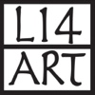
Addendum to 2026 Local 14 Consignment Agreement
I’m providing inventory sheets.
I’m not providing inventory sheets. I understand that by not providing this list I forfeit my right to be covered by Local 14 insurance in case of theft or damage.
Artist Name (print):________________________________________________
Artist Signature:___________________________________________________
Date:_____________________________________________________________

