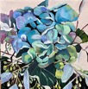
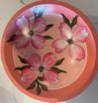

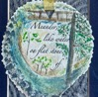
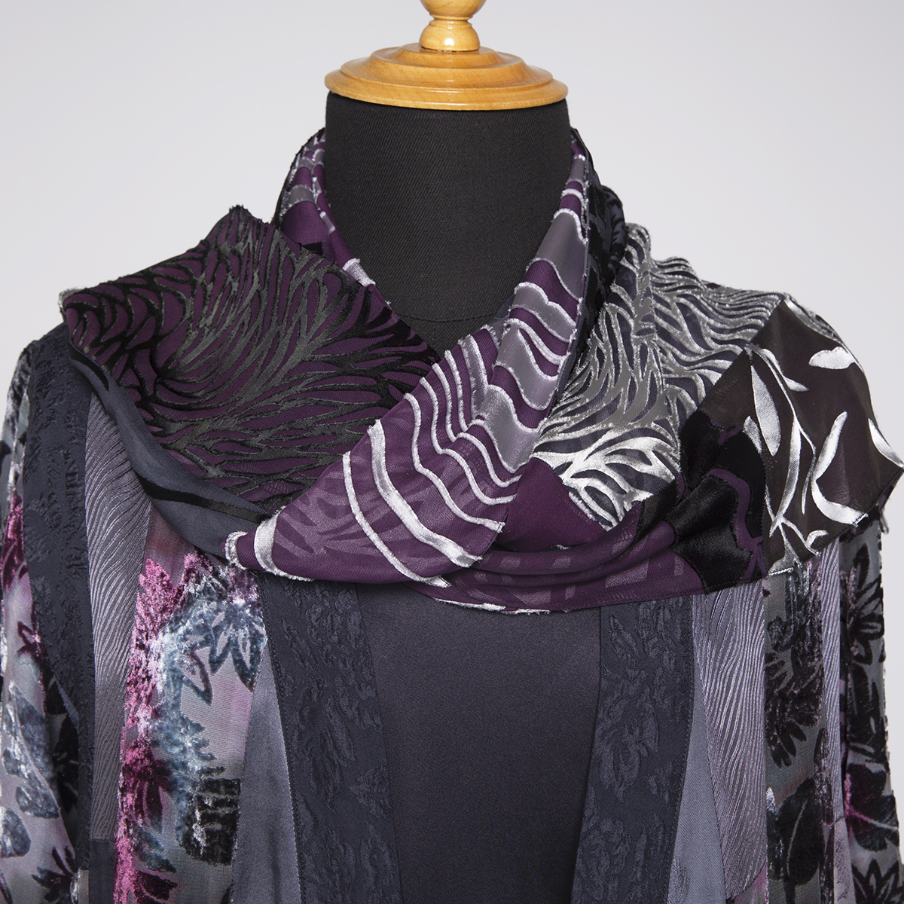
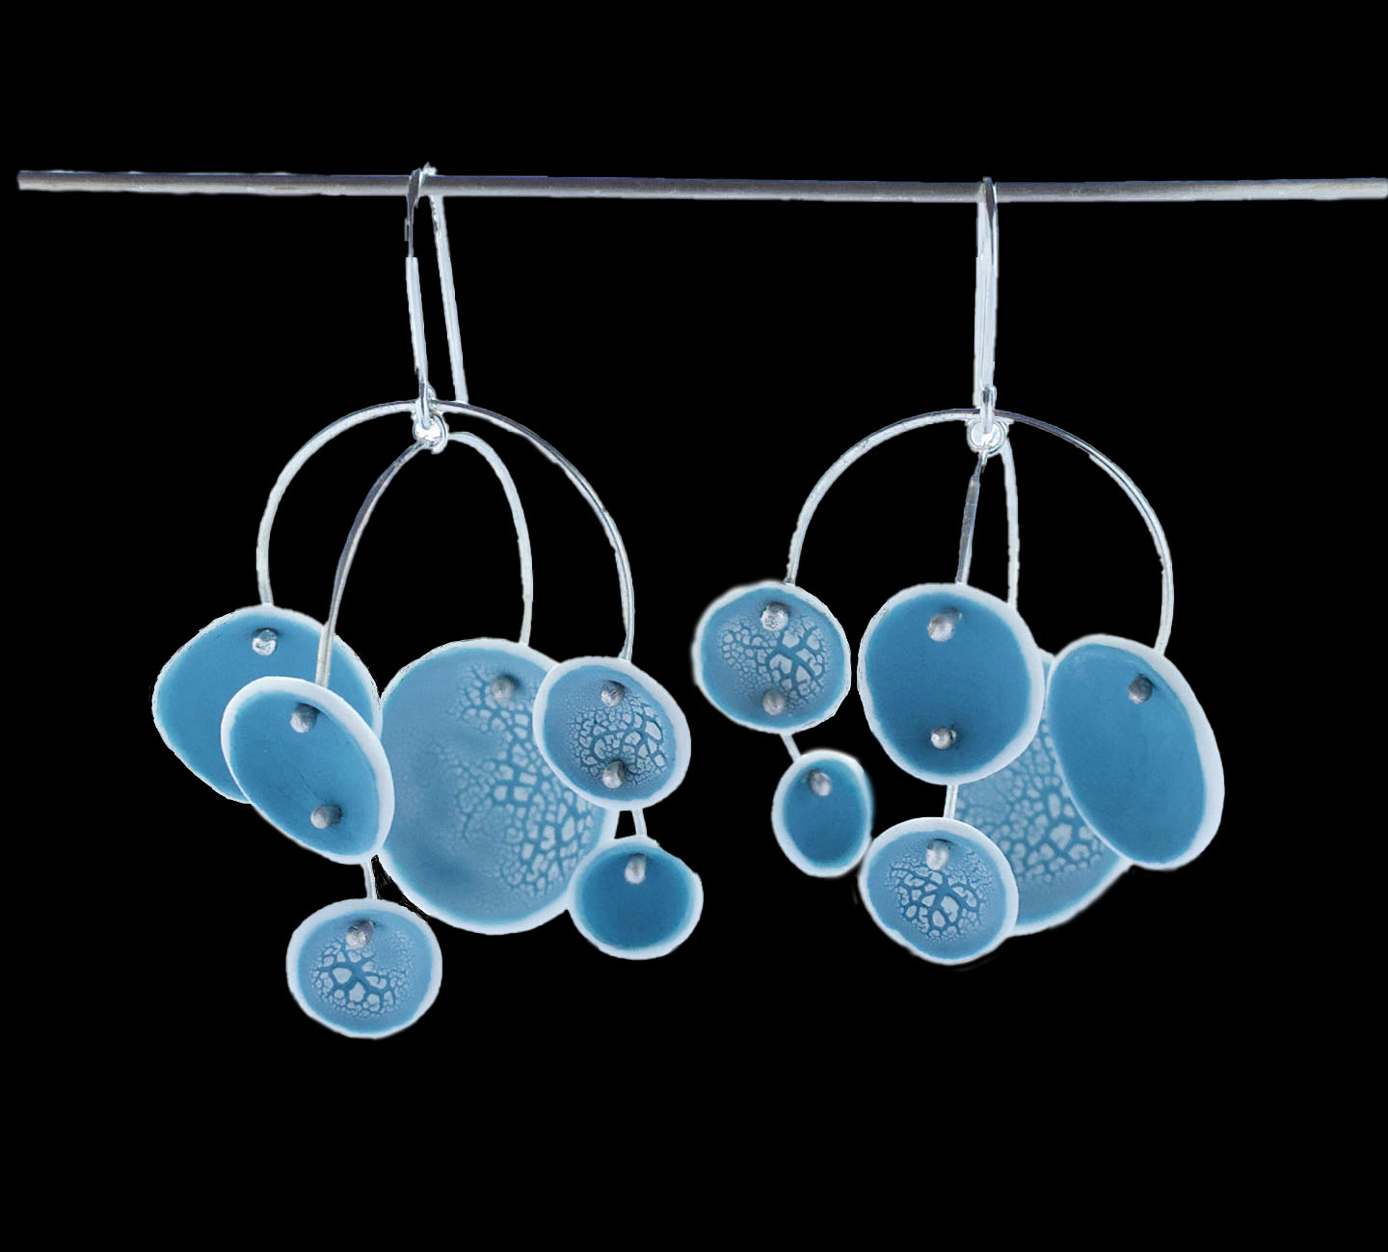
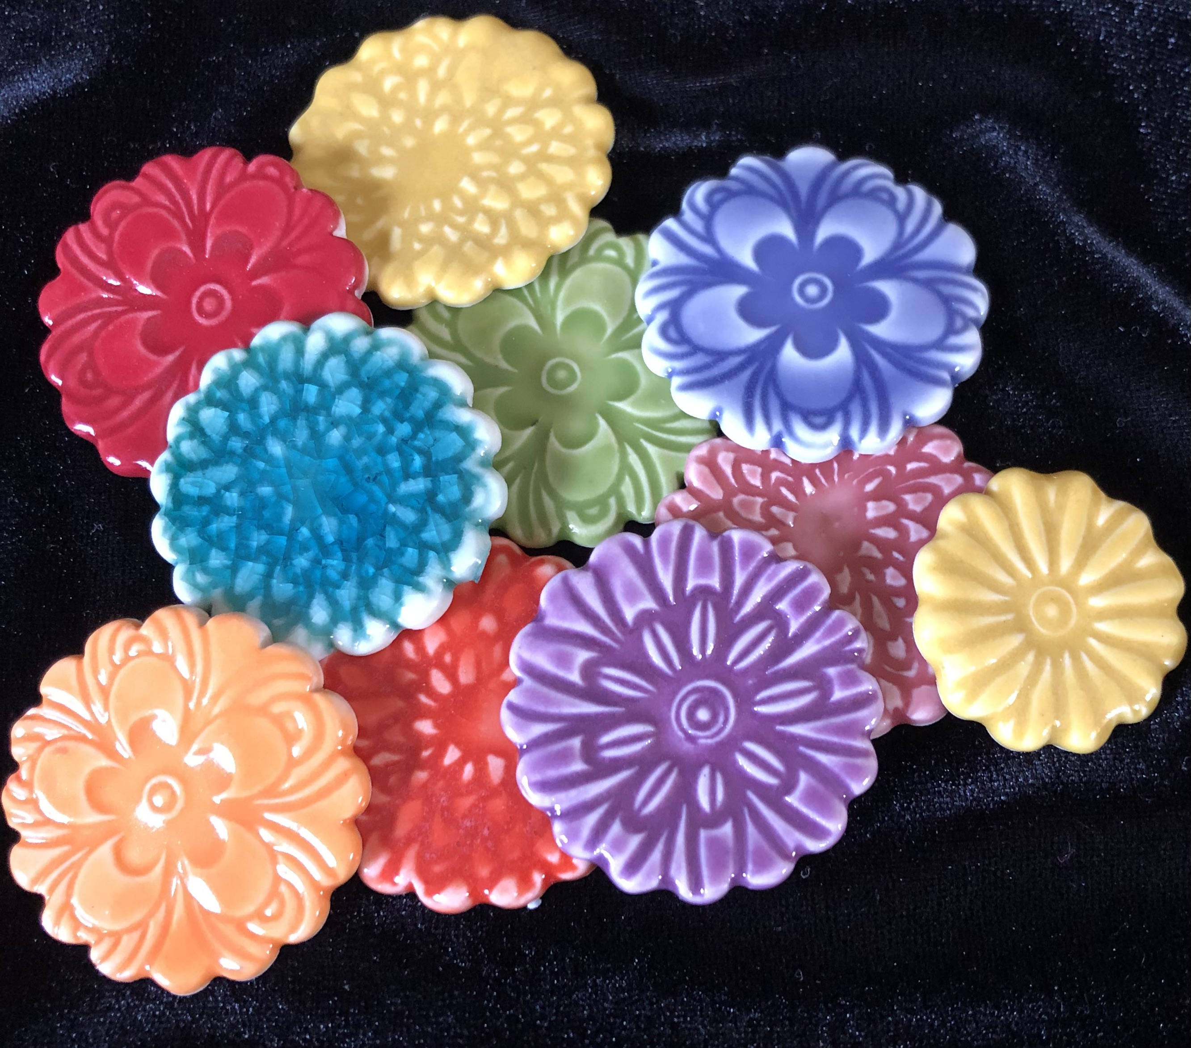

Local 14 Art Show & Sale • October 3, 4, & 5 • Miller Hall, World Forestry Center

DIRECTORS WELCOME TO OUR GUESTS
Welcome to the 58th year of Local 14’s Art Show and Sale on October 3rd, October 4th, and 5th at the World Forestry Center. Our show season begins with our Kick-Off Dinner on Tuesday September 2nd. At that time, we will be honoring our scholarship winners and sharing the information you will need for successful participation in the show.

Important Dates and Times:
Local 14 Hosted Kick-off Dinner: Tuesday, September 2nd at 6:00 pm
Location: Lakewood Center for the Arts
368 S State St, Lake Oswego, OR

Show Set-up: Thursday, October 2nd, 9am – 8pm
Show: Friday, October 3rd, 10am – 6pm
Saturday, October 4th, 10am – 6pm
Sunday, October 5th, 10am – 4pm

Publicity and Social Media:
Postcards will be available for pickup at the Kick-off dinner to distribute to your patrons. Among the guest artist documents on our website, a .pdf and .jpg version of our postcard will be available to download for your promotional purposes. Feel free to engage with Local 14’s Facebook and Instagram sites. If you haven’t already, please send your social media links to us if you wish to be promoted by Local 14. The links for our social media accounts are:
https://www.facebook.com/Local14Artshow/
https://www.instagram.com/l14artshow/

Show Packet:
Your Show Packet is available to download via our website: www.local14.org.

Work Hours & Load-In:
You will be sent a link via email to sign up for your show work hours. Your booth location information and load in/out instructions will also be emailed. We look forward to working with each of you and thank you for your energy, enthusiasm, and talent that you bring to our show! Please contact us if you have any questions.

Contacts:
Director: Terri Neal, ferg2neal@gmail.com , 503-750-7757
Guest Artist Liaison: Janis Childs, Liz Casale Local14GuestArtistLiaison@gmail.com
Jewelers Liaison: Carli Schultz glass@juiceglass.com
Layout: Mitzi Kugler mitzikart@gmail.com, Greta Schneider coppercreekdesigns@yahoo.com

